Lab 6:

Worksheet 1 (Monday)

1. Why is file processing useful for storing data?
2. Describe how you would read lines of text from a text file. Specify the class(es) you would use to accomplish this task.
3. Matching:

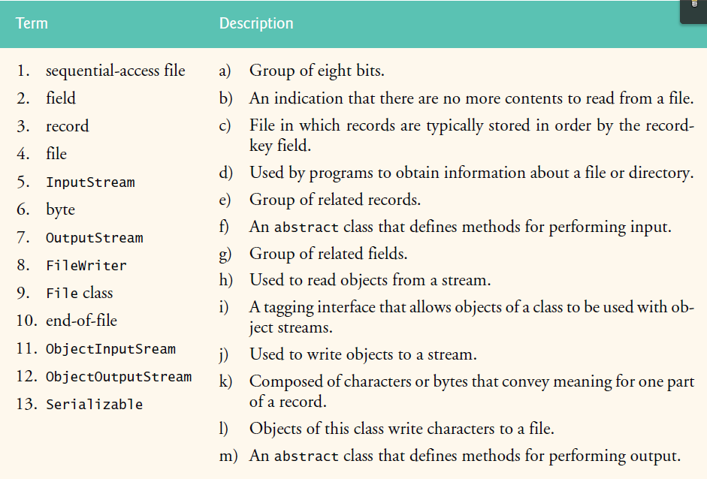

1. The following code segment should open a file for object output:



1. The following code segment should open a file for object input:



1. Filling the blank:
2. Programs use classes from package ___________________to perform Java file I/O.
3. Java creates three stream objects that are associated with devices when a Java program begins executing. These three objects are _________, _____________, ________________.
4. Java views each file as a(n) __________________
5. The following code segment should open a text file for reading with a Scanner.



1. The following code segment should open a text file for writing with a Formatter.



Submit *.java file into Lab 6 dropbox by Sunday midnight.